Joe Merrill 22FEB21
CMSC350 Project 3

UML Class Diagram

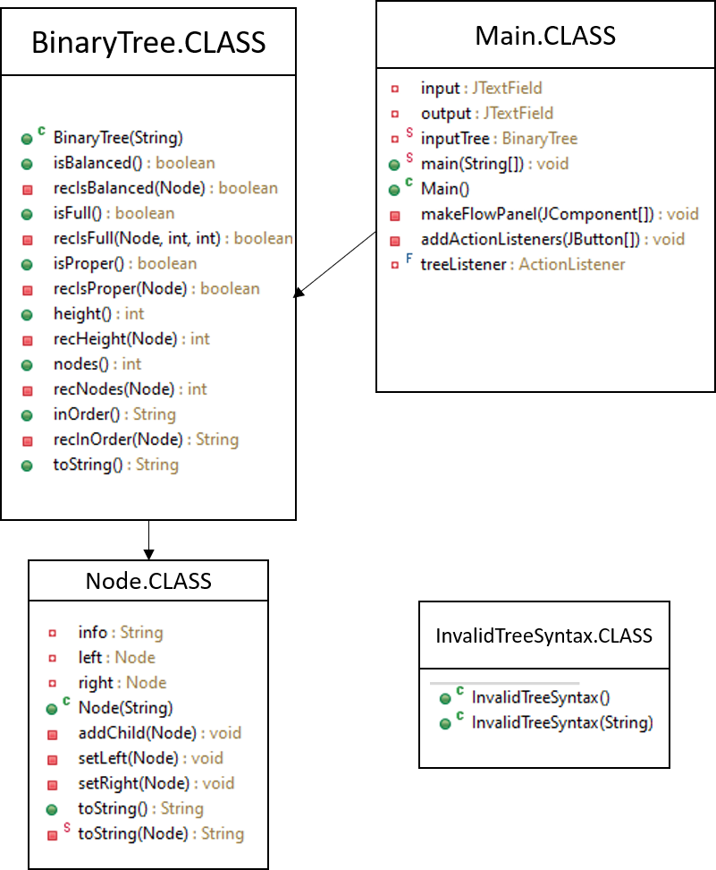

# | Input | Expected Output | Actual Output | Pass?
1 | 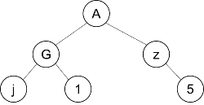  (A(G(j)(1))(z(5))) | Make Tree: (A(G(j)(1))(z(5)))  Balanced?: true  Full?: false  Proper?: false  Height: 2  Nodes: 6  In Order: (((j)G(1))A((5)z)) | Make Tree: (A(G(j)(1))(z(5)))  Balanced?: true  Full?: false  Proper?: false  Height: 2  Nodes: 6  In Order: (((j)G(1))A((5)z)) | YES
2 | 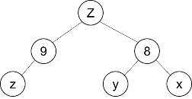  (Z(9(z))(8(y)(z))) | Make Tree: (Z(9(z))(8(y)(z)))  Balanced?: true  Full?: false  Proper?: false  Height: 2  Nodes: 6  In Order: (((z)9)Z((y)8(z))) | Make Tree: (Z(9(z))(8(y)(z)))  Balanced?: true  Full?: false  Proper?: false  Height: 2  Nodes: 6  In Order: (((z)9)Z((y)8(z))) | YES
3 | 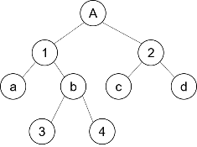  (Z(1(a)(b(3)(4)))(2(c)(d))) | Make Tree: (Z(1(a)(b(3)(4)))(2(c)(d)))  Balanced?: true  Full?: false  Proper?: true  Height: 3  Nodes: 9  In Order: (((a)1((3)b(4)))Z((c)2(d))) | Make Tree: (Z(1(a)(b(3)(4)))(2(c)(d)))  Balanced?: true  Full?: false  Proper?: true  Height: 3  Nodes: 9  In Order: (((a)1((3)b(4)))Z((c)2(d))) | YES

I’ve worked extensively with the concepts of trees, mainly decision trees, so this project made sense from the beginning. The pseudocode was fairly easy to organize, but the source code took quite a bit of research, trial, and error. Something I learned; using the Eclipse IDE allows you to build a ULM in the outline section of the IDE. I took screenshots and inserted them in the boxes in the ULM diagram. I’m hoping this helps me understand the ULM concepts better.

